HARVELELECTRIC ELECTRONIC STORE

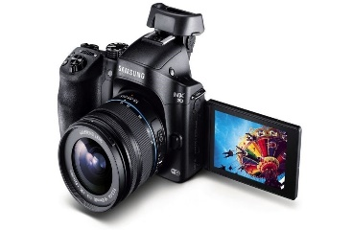

# Samsung D5300 DSLR Camera With 18-55mm Lens (Black)

Brand: [Samsung](https://www.jumia.com.ng/itel/)

**Price: $860**

Was ~~$900~~ 54%

+ shipping only for V.V.I.P clients.

## **Specifications**

## **KEY FEATURES**

* 30.4MP Full-Frame CMOS Sensor
* DIGIC 6+ Image Processor
* 3.2" 1.62m-Dot Touchscreen LCD Monitor
* DCI 4K Video at 30 fps; 8.8MP Still Grab
* 61-Point High Density Reticular AF
* Expanded ISO 102400; 7 fps Shooting
* Dual Pixel RAW; AF Area Select Button
* Dual Pixel CMOS AF and Movie Servo AF
* Built-In GPS and Wi-Fi with NFC
* EF 24-105mm f/4L IS II USM Lens

## **WHAT’S IN THE BOX**

* Canon EOS 5D Mark IV DSLR Camera with 24-105mm f/4L II Lens
* EF 24-105mm f/4L IS II USM Lens
* LP-E6N Lithium-Ion Battery Pack (7.2V, 1865mAh)
* LC-E6 Charger for LP-E6 Battery Pack
* Eyecup Eg
* RF-3 Body Cap for Canon EOS Cameras
* IFC-150U II USB 3.1 Gen 1 Interface Cable for DSLRs
* Cable Protector
* Wide Neck Strap
* Software CD-ROM
* Limited 1-Year Warranty

## **SPECIFICATIONS**

* **SKU**: CA701EL1BET1RNAFAMZ
* **Product Line**: KCC STORE
* **Model**: 5D Mark IV
* **Size (L x W x H cm)**: (HxWxD)7.45 x 9.0 x 11.15
* **Weight (kg)**: 1.8
* **Color**: Black